Community engagment assistant (voluntary)
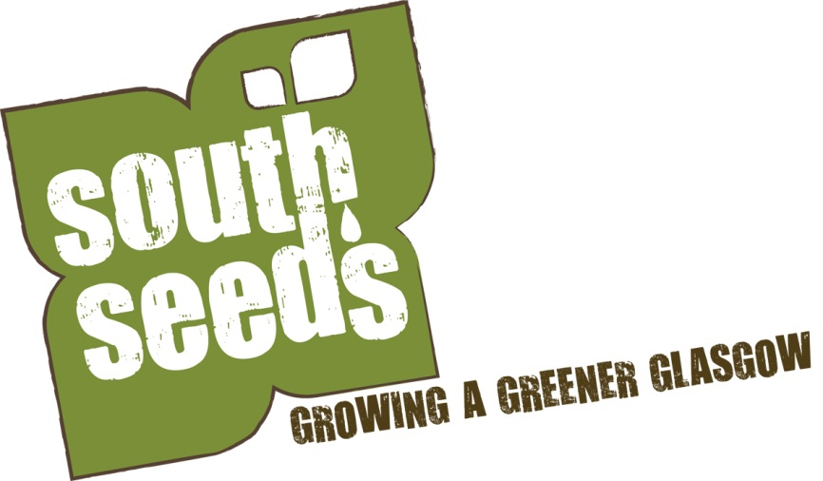

Job description
Responsible to: Community Development and Growing Officer
Hours of work: 2 days a week, with occasional weekend and evening work as required
Place of work: Govanhill, Crosshill, Queen’s Park and Strathbungo
Requirement: A basic disclosure
Timescales: We are looking for someone who can commit to volunteering over the summer

Job purpose:
To assist South Seeds with its community engagement work. Also assist creating new community garden spaces.

General responsibilities:
- To work as part of the South Seeds team.
- To support South Seeds work to create community gardens.
- To engage with project participants in a positive and constructive way and ensure their needs are met.
- To communicate effectively with the team.
- To work with team members to achieve goals
- To report on the success of tasks.

Person specification
Essential:
- A friendly manner
- Ability to fit in with a team
- Good communication skills

To apply
Please fill in the application form on the South Seeds website www.southseeds.org and email a copy to robin@southseeds.org by 5pm on 4th July 2013.
If you would like to speak to someone about this opportunity please call Robin, the Community Development and Growing Officer on 01464 636 3959 or email robin@southseeds.org.
For more information about South Seeds visit www.southseeds.org.

