Volunteering
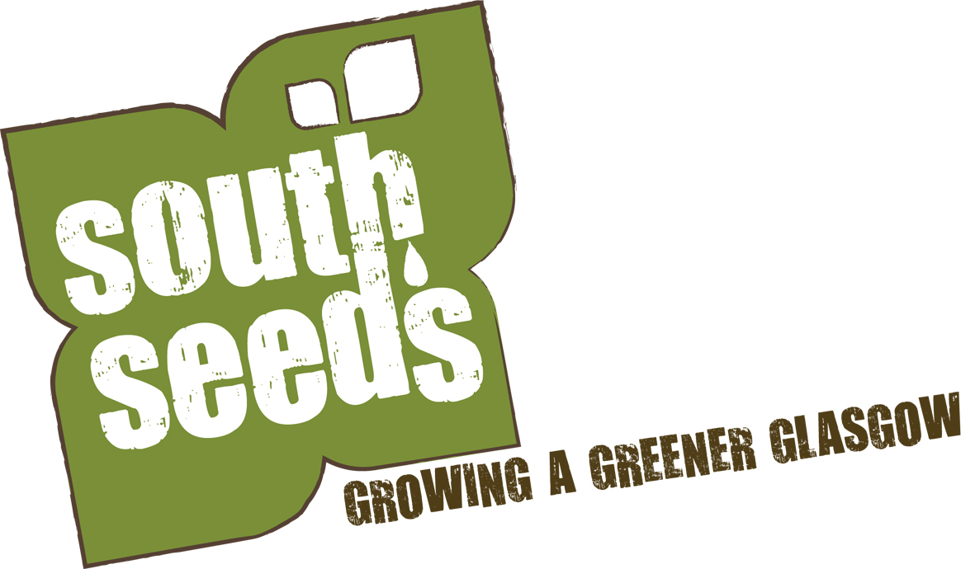
Request Form

The information provided on this application form will remain private and confidential and will be used only for the purpose of selection. Please complete all sections of this application form, and do not send a CV.

Your name:
Your address:
Your email Address:
Phone (evening):
Phone (day):
Mobile:

May we telephone you during the day? Yes/No
When would you be able to begin? (insert date)
1. Why does this opportunity suite you? (in no more than 100 words)

2. Have you ever been convicted of a criminal offence? If yes, please give details. (Declarations are subject to the provisions of the Rehabilitation of Offenders Act)

3. Are you in good health? Please give details of any health/disability problem(s) which may be relevant to the position applied for, and please describe below any reasonable adjustments which you feel should be made to the job itself which would enable you to carry out the work.

Please return your completed application form to:

robin@southseeds.org

by 5pm on the closing date.

Equal Opportunities Monitoring Form
South Seeds accepts its responsibility as an equal opportunities employer, and has adopted an Equal Opportunities Policy. Our aim is to ensure the fair and equal treatment of all job applicants, and to meet the requirements of equal opportunities legislation. You are therefore politely requested to complete the questions below. The information will not be used in any part of the recruitment process.
The data from this form will only be used to help us monitor the effectiveness of our Equal Opportunities Policy, and will not be used in any way in connection with short listing.
Please complete the following details in block capitals, answering all of the questions.
Job applied for _________________________________
What is your ethnic group?
 | White |  | Asian, Asian Scottish or Asian British
 | Scottish |  | Indian
 | Other British |  | Pakistani
 | Irish |  | Bangladeshi
 | Any other white background |  | Chinese
 |  |  | Any other Asian background
 | Black, Black Scottish or Black British
 | African |  | Mixed
 | Caribbean |  | Any mixed background
 | Any other Black background
 |  |  | Other ethnic background
(Please note these classifications are recommended by the Commission for Racial Equality)
Please tick the appropriate answers:
Sex:
Female
Male

Do you consider yourself to have any disabilities?
Yes
No

Age group:
Under 25
25 – 34
35 – 44
45 – 54
Over 54

