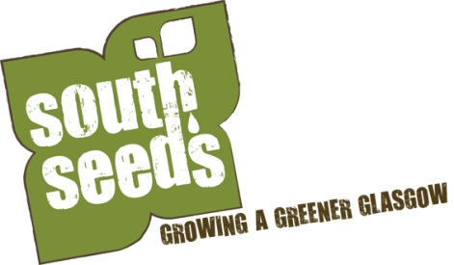

South Seeds is looking for 3 motivated individuals
to join the Board of Trustees

Background
South Seeds - set up by local residents in 2011 - was the first Scottish Charitable Incorporated Organisation (SCIO). The organisation is owned by its members - who are local people, keen to see the Southside of Glasgow, an area which suffers from regular negative representation in the media, improve. The membership vote for Charity Trustees at the AGM, further Board Members can be co-opted during the year. The Board of Charity Trustees has evolved since its first beginnings. The Board meet throughout the year and support staff as and when required.
At South Seeds AGM on 28th April 2014, the membership adopted the Climate Challenge Pledge. This complements South Seeds’ aims of advancing environmental protection and improvement of the Southside of Glasgow.
South Seeds have delivered two Climate Challenge Funded projects, and through this work we have
- won two awards, the Saltire Society Innovation in Housing Award 2013 for our Energy Snapshot report and the Greener Together Award 2014
- doubled our target of establishing food growing space in densely populated areas of the Southside of Glasgow
- identified and trailed a number of solutions tailored to reducing energy use for local property types
- provided support and direction to other community groups across Scotland attempting to engage their own local residents to reduce energy demand
South Seeds has run other projects with a view to improving the Southside. The sculpture project, funded by The Big Lottery’s Awards for All, enabled local people to create local stone sculptures which are now displayed through the area. South Seeds partnered with a local community group on a project, funded by Zero Waste Scotland, to clean up particular streets in Govanhill, where 80% of properties are owned by private landlords.
For more information about South Seeds see www.southseeds.org
What we are looking for
Currently, we have five Board Members and we are looking to strengthen this group.
Board Members are expected:
- To contribute relevant experience, expertise and insight into the development of South Seeds.
- To provide effective support and act an as accountable member of the Board.
- To ensure the sustainability and long term financial viability of South Seeds.
We need individuals who are dedicated to making a difference to the Southside of Glasgow and people’s lives, regardless of their background or personal circumstances. Ideally you will be representative of the community of the Southside of Glasgow, have experience of South Seeds services and/or experience of organisational development.

How to apply
Please complete the application form below.
Return your completed form to lisa@southseeds.org by 9th June 2014. Applications will be considered at the June Board meeting and successful candidates informed before July.
Please note we are also recruiting for two part time energy officers, the deadline of that recruitment process is 16th June, there is a different application form and the completed form must be sent to a different email address. Check www.southseed.org if you would like to know more.
APPLICATION FORM
Please fill out all sections
Your name:
Your address:
Your email address:
Phone (evening):
Phone (day):
Your mobile:

1. What is your interest in joining the board of South Seeds (300 words max)?

2. Are you a Director or Trustee of any other organisation(s), if so please list?

3. Let us know any other information you consider relevant (300 words max).

Signature*________________________________ Date__________________________
* An electronic signature is sufficient

