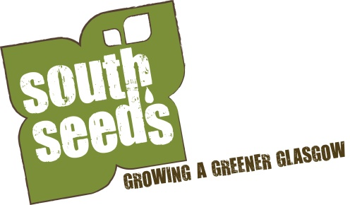
Form to express interest in becoming a
South Seeds sessional community garden worker

Please complete all sections of the form and email it to lucy@southseeds.org by close of business on 26 April 2018.
Your name

Your address

Contact number

Email

What are you currently doing?
(400 words max)

What is your experience of gardening or growing food?
(400 words max)

What is your experience of working with people?
(400 words max)

Give us the name and telephone number of somebody you have worked with (in a voluntary or paid capacity) and would be willing to give you a reference?

During the first two weeks of May we will invite people, who have submitted an express interest form, in for a cuppa and chat to find out more. Unfortunately we will may not be able to invite everyone in, so make sure you put enough information on this form so we can figure out if you are a good fit with South Seeds.

